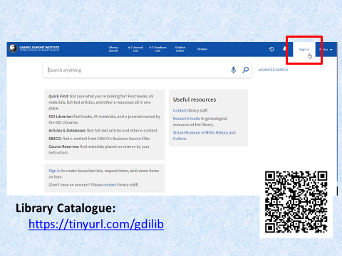

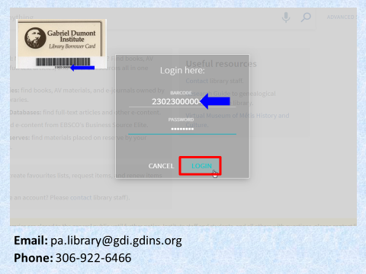

Slide 1
Welcome to the GDI Library series of video tips.

Due to COVID-19 precautions, walk-in access to the library will be limited for the foreseeable future. If you do need some in-person time in the library and you’re not exhibiting COVID symptoms, you can reserve time for a visit.

Slide 2
There are multiple ways that you can book in-person time at the Prince Albert library, Your first option is to do so thorough your library account. Get started by going to the library’s catalogue. Use the URL on your screen, or scan the QR code on your mobile device.

Slide 3
Log in to your account using the barcode from your library card, and the password you set up when you were issued this card.

If you don’t know your password or your barcode, please contact library staff.

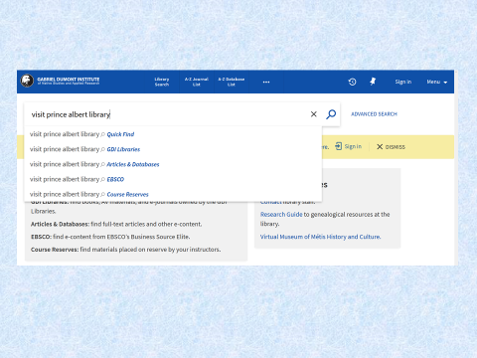

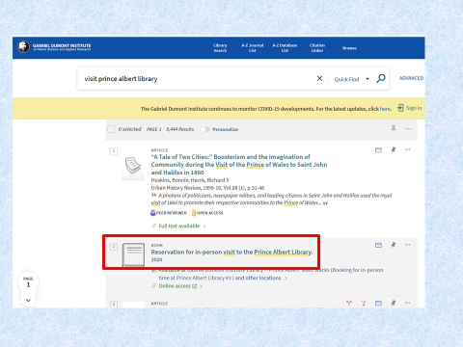

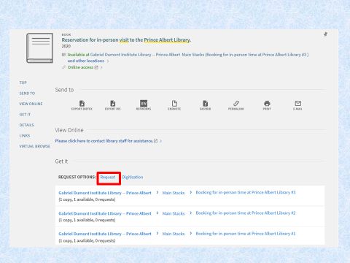

Slide 4
After you’re logged in to your account, do a search for “visit prince albert library.”

Slide 5
Click on this item…

Slide 6
…and then scroll down to the “Request Options” area.

Click on the “request” button…

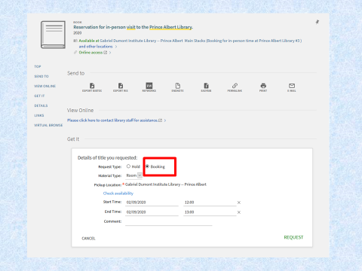

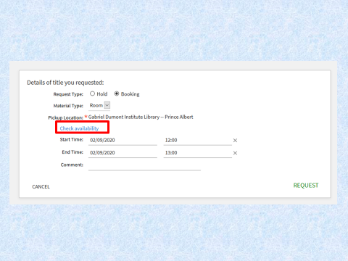

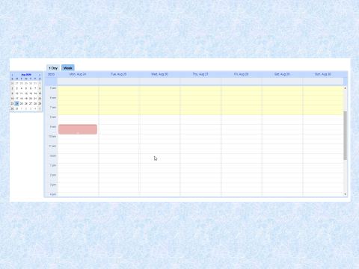

Slide 7
…and fill out the form. Choose the “Booking” option under “Request Type,” and “Room” under “Material Type.” The pickup location should default to Prince Albert. Choose a start date and **time, and an end date and **time. Bookings can be up to 3 hours in length.
**Please note that the booking clock is a 24-hour clock.

Slide 8
You can view availability by clicking on the “Check Availability” link.

Slide 9
White time slots are available; pink and yellow indicate that the library is closed, or that bookings for a certain time are already full.

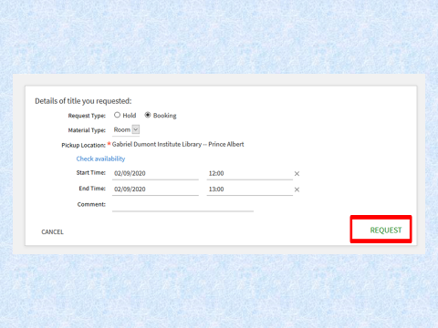

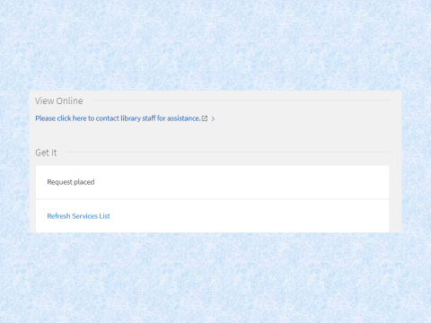

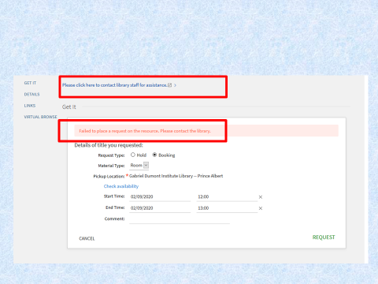

Slide 10
When you’ve filled out the booking form, click on the “Request” button.

Slide 11
Congratulations! You’ve booked your visit to the GDI Library.

Slide 12
If you receive an error, first check availability to ensure that the time slot you want is available. Ensure that your booking is for 3 hours or less, and that you have 5 or fewer booking requests on your account. If you’re still having problems, click on the link in the record for options to contact staff.

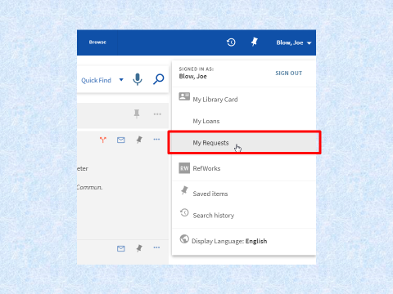

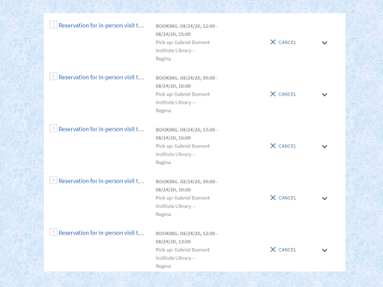

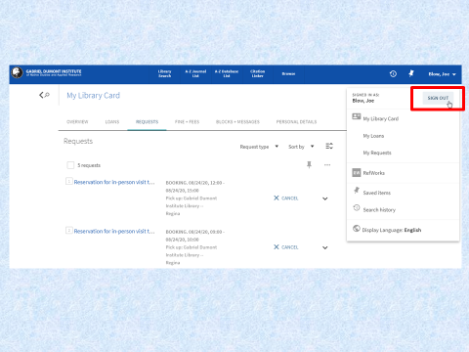

Slide 13
To see all of your requests, ensure you are signed into your library account, and click on your name in the top right corner of the screen, and select “My Requests.”

Slide 14
From this page, you can view your bookings, and cancel any that you may no longer need.

Slide 15
Make sure to sign out of your account after you’ve finished.

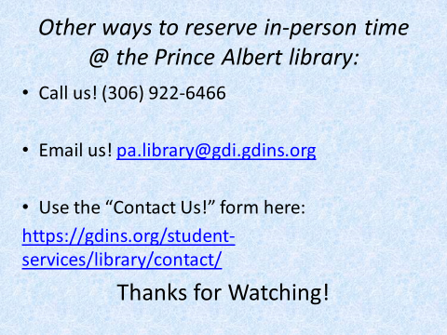

Slide 16

If you are unable to book in-person time through the GDI library catalogue, here are other ways we recommend contacting us. Feel free to do so with any questions about available library services.
Thanks for watching!

