**Title Slide**

Welcome to the GDI Library series of video tips.

This video will explain how to request that library materials from other branches of the GDI Library be sent to your local branch for you to use.

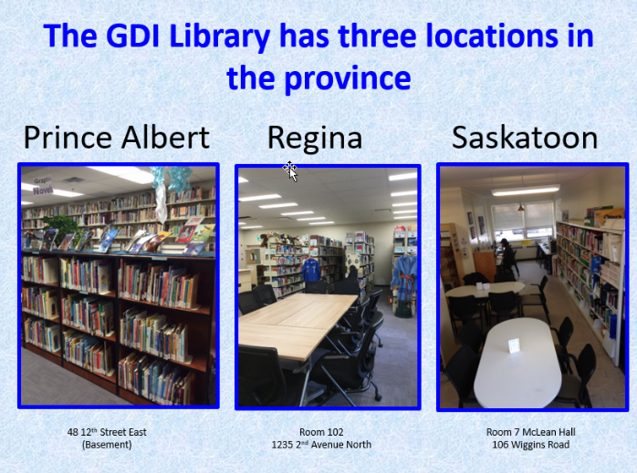

**Slide 2**

The GDI Library has branches located in Prince Albert, Regina, and Saskatoon. If you are a current student or employee of any of the Institute’s programs, you can request library materials from GDI Library branches across the province. Please note that this service is not available to public borrowers or alumni of the Institute, and that certain library materials may not be eligible for this service if their size, weight, or value exceed what can be sent through the mail.

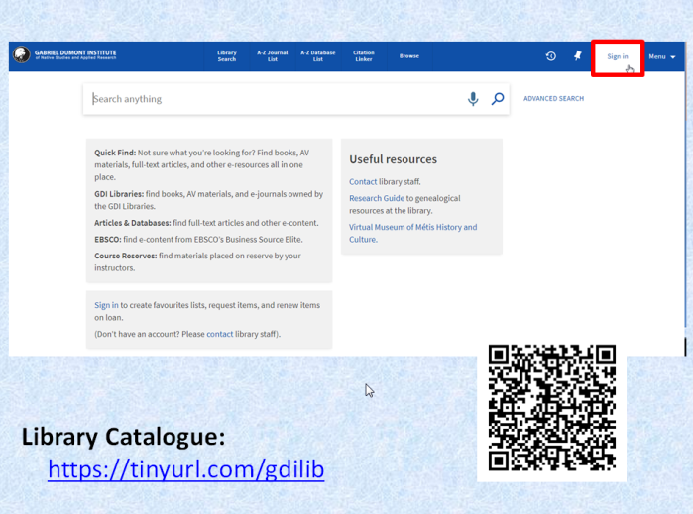**Slide 3**

Get started by going to the library’s catalogue. Use the URL on your screen, or scan the QR code on your mobile device. Click on “sign in” at the top right corner of your screen.

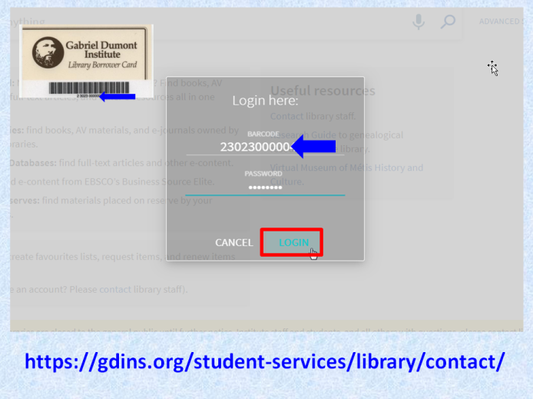

**Slide 4**

Log in to your account using the barcode from your library card, and the password you set up when you were issued this card.

If you don’t know your barcode or password, please contact staff at the branch closest to you.

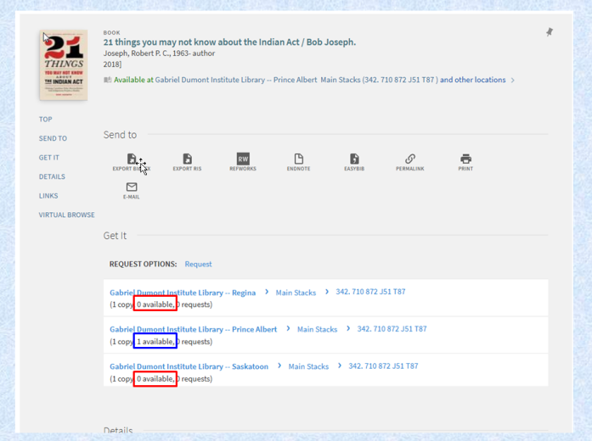

**Slide 5**

After you’ve logged in and done a search, you may find useful material that is not at your local branch, either because it hasn’t been purchased, or because the local copy is on loan to someone else.



**Slide 6**

Stop and check to see if the item is available elsewhere in your community – perhaps at the public library, or at another post-secondary library to which you have access. If the item is available, please borrow it from one of your other local options – it will be faster for you, and it will save us the cost and risk of loss associated with mailing library materials. If you can’t find another local source for the material, though, go ahead and request it from GDI.

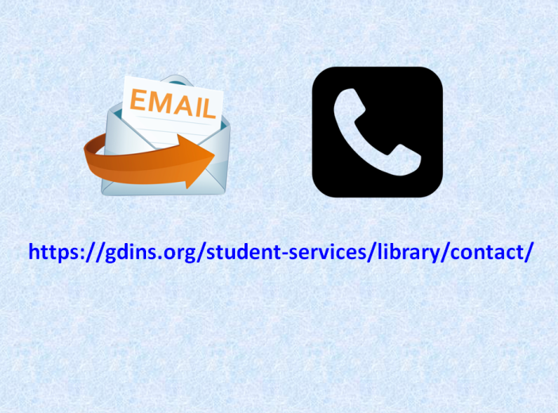

**Slide 7**

There are several ways to request material from other branches. You can contact staff at your local branch in person, by email, or by phone to ask that they place the request for you …

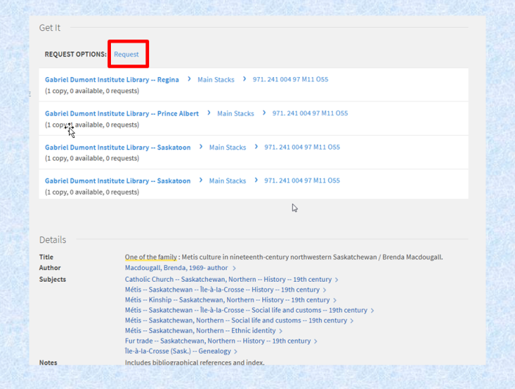

**Slide 8**

…or you can place the request yourself in the library catalogue. When logged in to your library account, click on the “Request” link in the “Get It” section of the catalogue record….

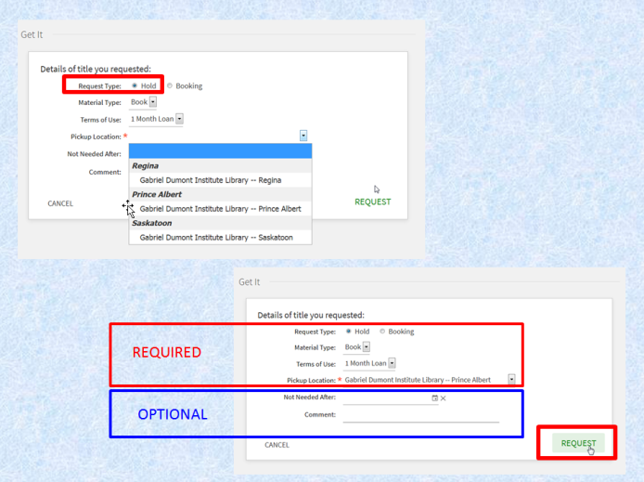**Slide 9**

…and fill out the form. Choose “Hold” as your Request Type; the Material Type and Terms of Use should provide default options for you to select, and the Pickup Location should be your local branch of the library. The “Not Needed After” and “Comment” fields are optional. When you’ve filled out the form to your satisfaction, click on the “Request” button.

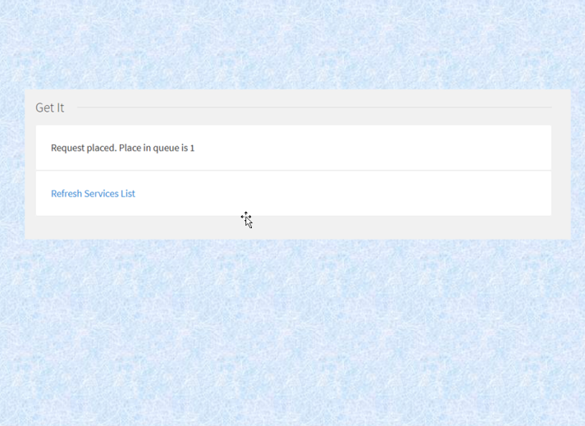

**Slide 10**

Congratulations! You’ve successfully requested library material from another branch. You’ll receive an email when the requested item is ready for pickup (usually within 3 to 10 days).

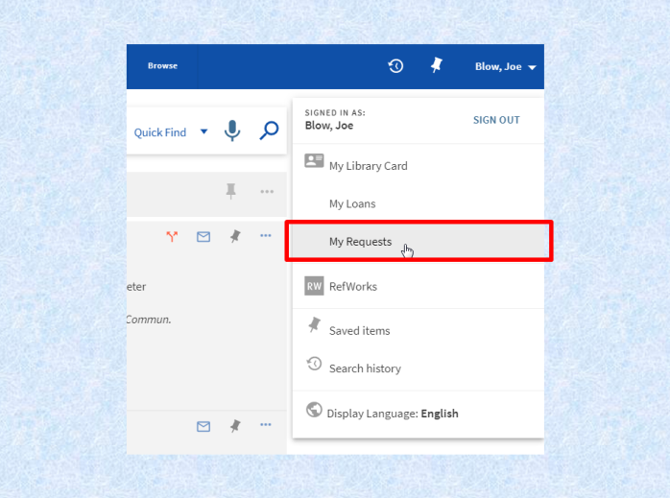

**Slide 11** To see all of your requests, click on your name in the top right corner of the screen, and select “My Requests.”

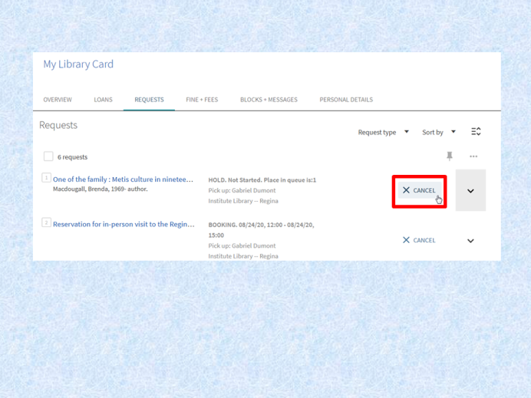

**Slide 12**

From this page, you can view your requests for items from other branches, and cancel any that you may no longer need.

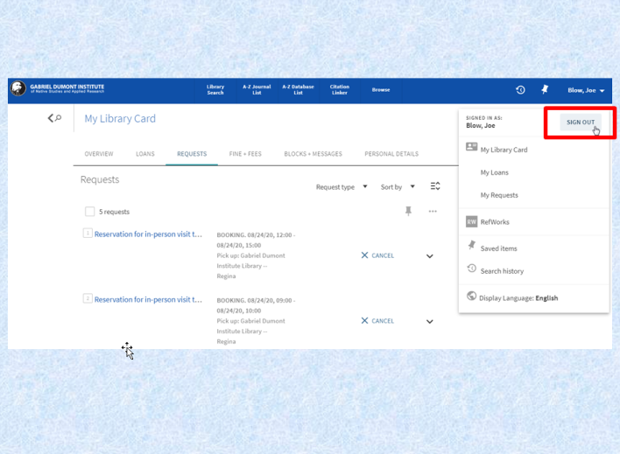

**Slide 13**

To protect your privacy, be sure to sign out of your account after you’ve finished.

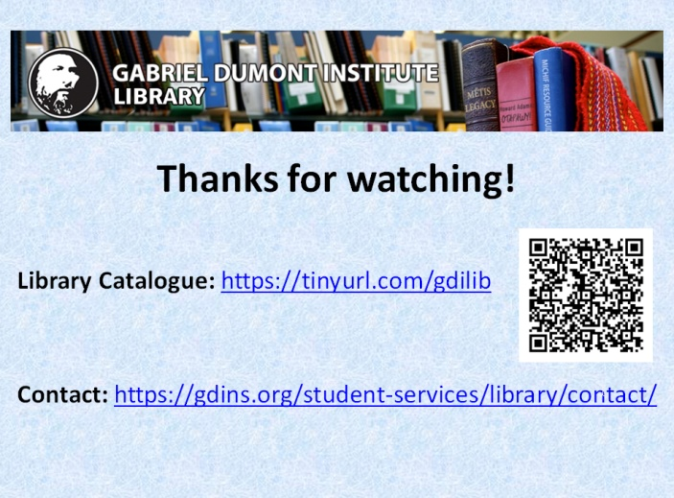

**Slide 14**

Thanks for watching! Be sure to contact staff if you run into difficulty, or have other questions about library services.